The Egyptian Proxy War With Ethiopia:

Why Are Some of Our People Helping Them Win?

Part II article that focus on external forces that exert an influence on deteriorating conditions in Ethiopia.

April 20, 2021

“A compromise to Egypt’s water share is a red line, and our response [if our water share is affected] will affect the stability of the whole region,” …
(A recent comment made by Egyptian President Abdul Fattah al-Sisi)

Some Ethiopians seem to be on the wrong side of an Egyptian proxy war against their own country. As ethnic-based killing and violence explodes in Ethiopia, the country has become a place where gruesome crimes against other human beings are committed with little remorse or accountability. It could trigger more massive killings, even genocide.

It is the responsibility of those who value every human life and the national unity of Ethiopia to do something about it. For years, Egypt has been attacking Ethiopian national unity by stoking the fires of division. It is finding fertile ground among ethno-nationalists, but is also strongly reinforced by Ethiopia’s governmental model of ethnic federalism and our ethnic-based Constitution, which could also be called institutionalized tribalism.

We, the people of Ethiopia, have a choice to say no; however, instead, some among us are fanning the flames of ethnic-based hatred, the desire for ethnic-based vengeance for crimes past and present and the dehumanization of others, based on identity. Never before have we seen such a widespread movement of ethnic-based hatred and violence as is now sweeping across the country. If it continues, we exponentially increase the risk of losing the whole country to anarchy and violence, played out against each other, our fellow-citizens.

No single ethnic group will win if our country breaks apart, like Yugoslavia. If we participate in the destruction, or do not try to rise above it, or if we fail to warn others of the danger, who can we blame but ourselves? Those of us who care about living in peace and greater prosperity with each other, must get involved; however, as fear increases, many are giving up hope of national unity and; and instead, are returning to their ethnic-based communities as they are put on the defensive.

It is important to consider what is behind all of this and how we can resist falling into the trap that will defeat us all. We are not simply looking at Ethiopians, but we must look beyond our borders to be more fully aware of external forces directed against us and our peace. Egypt is one of these external forces, and has been for years, even now openly speaking out about it

What does Egypt want?

1) Control of the Nile

Egypt wants complete control of the Nile. As mentioned, this is not new to us, but has been openly articulated by Egyptian President Morsi; and now by President al-Sisi, who recently warned reporters at a press conference on March 29, 2021, in response to the dispute with Ethiopia over the Grand Ethiopian Renaissance Dam (GERD) and Egypt’s water rights, threatening the following:

“Nobody will be permitted to take a single drop of Egypt’s water, otherwise the region will fall into unimaginable instability,”….

“If it happens, there will be inconceivable instability in the region that no one could imagine,”…

“A compromise to Egypt’s water share is a red line, and our response [if our water share is affected] will affect the stability of the whole region,” …

“Hostile action is ugly and has significant repercussions that could last for years, because nations do not forget,”

Morsi had also made grim threats to Ethiopia while history documents the clear exclusion of Ethiopia from any previous decision-making in regard to the use of Nile waters, despite the fact that 85% of the water originates in Ethiopia. The last agreement divided the water between Egypt, who was given 66% of the allocation, and the Sudan, who was given 22%, with the rest to evaporation. Ethiopia received no allotment.
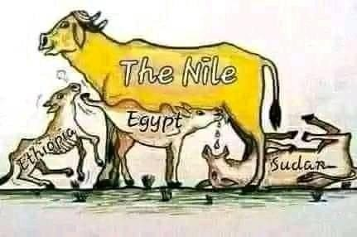
The GERD is anticipated to provide 6,200 megawatts of hydroelectric power to a region lacking it. Approximately 60% of Ethiopians do not have electricity, while 99% of Egyptians are said to have it due to hydroelectric dams in Egypt, on the Nile River. Now, the argument centers on the speed of filling the dam, as well Egypt demanding a binding legal agreement that guarantees Egypt control over the flow. Experts have indicated that the hydroelectric dam will not have a significant impact on the flow of water to Egypt.
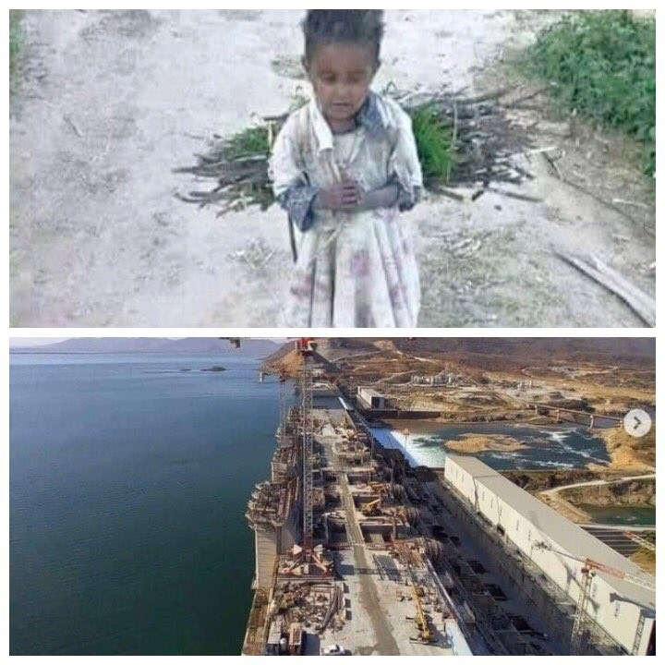
What President al-Sisi must not understand is that Ethiopia does not receive a single drop of water from Egypt. Instead, it is actually Ethiopia that could have made these kinds of unwise and irresponsible statements; however, Ethiopia has chosen not to do so because in this global society, we must find ways to share resources and to work together for the common good, especially with our regional neighbors.
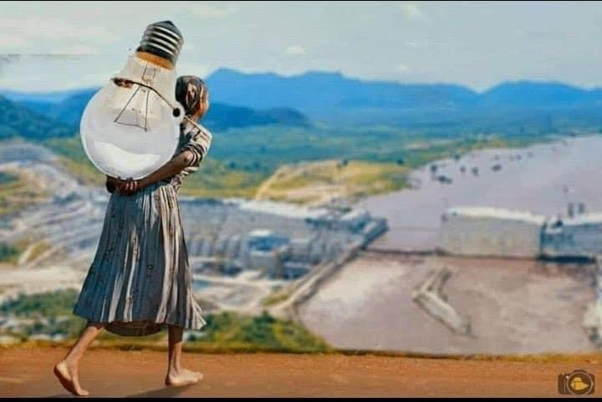

2) Control of the Red Sea Shipping Lane

The second goal of Egypt has been to maintain control of the Red Sea. The Red Sea may be one of the most important sea lanes in the world. Prior to the former regime, Ethiopia had a navy with access to the Red Sea and its ports; but now, because of the politics of ethno-nationalists and separatists, Ethiopia was made to be completely landlocked. One analyst, Gregory R. Copley comments on this in his article from June 7, 2013, Egypt’s Instability Triggers a New Proxy War Against Ethiopia and its Allies:

Egypt’s Morsi Government has initiated a return to covert war against Ethiopia, which controls the source of the Blue Nile, Egypt’s and Sudan’s principal source of water. The result will almost certainly lead to an increased level of insecurity in the strategic Red Sea/Suez sea lane and in the upper Nile riparian states, such as South Sudan, with some impact on global energy markets. Certainly it promises to see greater instability in the Horn of Africa at a time when Western media portrayals hint at a return to stability in, for example, Somalia.

He goes on to say:

The campaign includes a major media offensive at the alleged threat, and also included the commitment of major political, intelligence, and military resources to a trenchant [incisive] reversal of Egypt’s brief period of rapprochement [efforts to bring together] with Upper Nile riparian states, particularly Ethiopia.

This amounts to a full — even expanded — resumption of the indirect war to isolate Ethiopia politically and economically and to ensure that it cannot attract foreign investment and political support. It also attempts to ensure that Ethiopia’s main avenues for trade, through the Red Sea ports in Eritrea, Djibouti, and Somaliland, become closed to it.

At the time, he was speaking about President Morsi, but President al-Sisi’s position is obviously no different, especially in light of these recent comments about the Nile and the fact that a large percentage of income for Egypt comes from their domination of the Red Sea.

A Brainwashing Media Campaign?

For at least a decade, I have been aware of efforts on the part of Egypt to incite division between Ethiopian ethnic groups, particularly the Oromo, the Amhara and the Tigray. Even I was approached in an attempt to deepen the animosity between my own ethnic group, the Anuak, in regard to others.
One of the chief inciters was Egyptian. His name was Dr. Muhammad Shamsaddin Megalommatis, possibly a fake name and persona, who I believed had to be confronted with his grandiose efforts to spread and deepen hate and conflict among Ethiopians, but at the same time, Ethiopians had to be warned not to fall for it. This was eleven years ago.

At that time, I sent an open letter to Ethiopians and Africans regarding Dr. Muhammad Shamsaddin Megalommatis, click at the link to read the letter in English
http://www.solidaritymovement.org/100803MUHAMMAD_SHAMSADDIN_MEGALOMMATIS.php and click here for the Amharic http://www.solidaritymovement.org/amharic/100803Megalomatis.pdf, warning Ethiopians to consider whether this man was seeking a fragmented and weakened Ethiopia/Horn of Africa so we all could be divided, controlled and exploited. At the time, I posed the following question:

Did you ever wonder how and why Dr. Megalommatis manages to write article after article claiming love for the Oromo—with 22 articles focused on just the Oromos in only the last month—or other “subjugated people” of Ethiopia as he labels them; while claiming deep hatred, almost exclusively directed against the Amhara, who he calls “beasts”—with 34 articles in the last month, where he viciously blasts Amhara and/or “Fake Ethiopia?” Why is he spending so much time and effort on stirring up such anger? Is he being paid for it and if so, by whom?

His was an intense media campaign that began over a decade ago with the goal of brainwashing some of the ethnic groups in Ethiopia, hoping to destabilize the country, similar to al-Sisi’s recently stated goal. Undoubtedly, it has helped to fuel some of the fires burning across the nation now, that might achieve the goal of destabilization. To what degree has this kind of hate-mongering incited what is going on now? Sadly, it is working.

STOP IT! JUST STOP IT!

The ethnic-based killing of human beings in Ethiopia has reached such a tragic point that one feels like blocking one’s ears, closing one’s eyes and screaming out at the top of one’s voice, “STOP IT! JUST STOP IT!”

Each killing ends a human life; a life given breath, value and purpose by our Creator. Each death is of one individual person, abruptly taken away as if that one life was meaningless; yet, every human being has a name, a family, a God-given purpose and a future that now will never be realized. Those who kill have forgotten— or never understood— their real identity is as a human being— before all other identity factors— especially ethnicity.

People who commit such inhumane acts cannot be defined by ethnicity, as they do not represent many others within their identity group who vehemently condemn such acts. However, what accounts for the ethnic hatred, mob mentality and the hardening of the hearts and souls of those who commit these crimes and jeopardize our collective future?

Recently, I released an alert, warning Ethiopians of the danger that lies ahead if we do not do anything to stop it. Click at the link to read the alert: http://www.solidaritymovement.org/210407-Ethiopia-is-at-Risk-of-Becoming-a-Failed-State.php. That danger is a possible failed state. It will affect all of us if do not take action against this explosion of ethnic-based hatred, the spirit of revenge, brutal killings, violence, destruction and the displacement going on all over Ethiopia. Many of us, especially our youth— some of whom are participating in it— may not even live to regret it. Let us protect them from falling into this trap now!

Most of the ethnic-based violence has been in Oromia, Benishangul-Gumuz, Amhara and Tigray Region; however, in the days following the article’s release, we learned of many more killings and many thousands of more persons displaced in places like the South, Afar, and the Somali region. On April 17, a shocking videos and pictures captured the tragic killing of innocent people in the town of Ataye in North Shewa. People were targeted due to their being of Amhara ethnicity.
Those who are targeting others by ethnicity do not represent many others of their same ethnicity; yet, it has created a rush back to one’s ethnic group for “safety” due to heightened fears everywhere. With every killing, the desire for retaliation increases. This is an enormous problem in that it creates cycles of vengeance and loss.

For the last several decades, we have been seeking our freedom and rights; let it not be destroyed before our eyes. Instead, let us now join together to work out our differences and to make an effort to find enough consensus to enable us to move ahead. We must resist the temptation to fall into strongholds of lies, manipulation and exploitation by foreign forces. Let us end ethnic-based politics, which are a threat to all of us.

Let us seek the wellbeing of others, “putting humanity before ethnicity” or any other differences, and upholding the freedom and rights of all our people for not only is it right to care about our neighbors, near and far, but “no one or no one ethnic group will be free until all are free.”

Let the conversation begin. Most importantly, may God help Ethiopians to know that whenever you kill another person, you kill a part of yourself. We are a country that desperately needs truth, healing and forgiveness. We have made many mistakes. Let us make a turn around and make it right this time. May God help us to love our neighbors, near and far!

__________________________________________________________
For more information contact Mr. Obang Metho, Executive Director of the SMNE. Email: Obang@solidaritymovement.org

