Institutionalized Tribalism: Ethiopia’s Constitution and Ethnic Federalist Government Increase the Risk of Instability in Ethiopia

April 15, 2021

Institutionalized tribalism, in its worst form, was officially adopted under the deceptive name of Ethnic Federalism, 30 years ago, under the former government led by the Tigrayan Peoples Liberation Front (TPLF). It was a way to placate some ethnic groups; however, the result of it is now threatening our survival as a country.

It was purposely set up to ensure that Ethiopians did not come together under a consensual agreement for the benefit of all Ethiopians, which was a threat to the goals of the TPLF who sought to achieve perpetual hegemony, as per their manifesto: “TPLF/EPRDF’s Strategies for Establishing its Hegemony & Perpetuating its Rule,” published in 1993.

One of the goals of this structure was to ethnicize Ethiopia’s citizens, a divide and conquer formula so people would not achieve unity; but instead, live as separate ethnic groups, not even as individual citizens. It was and still is a recipe for destruction. The maturing of this indoctrination has now reached to its pinnacle as young people start to believe that their primary identity is their tribe and that their religion, actually practiced, is “tribalism.”
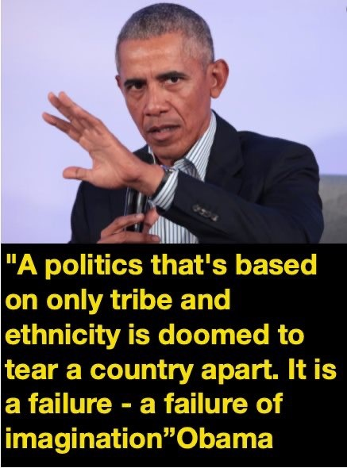
This is anti-harmony, anti-development, anti-peace and anti-humanity because human beings are social creatures, who depend on each other for survival; but in the case of the present Constitution and its toxic ideology being pushed on the people, it comes at the expense of everyone, even if it takes a while. Sadly, it has backfired with vicious force against the people of the Tigray Region, many of whom are innocent of any crimes, but because they are defined under this toxic and dangerous ideology as an ethnic group, guilty of whatever the TPLF leaders have done, they are feeling the great and undeserved pain of this association. Under a more inclusive individual-based system, this could have been more easily avoided.

Yet, this tribalistic approach is reinforced by the Ethiopian Constitution that describes the citizens of the country as: “nations, nationalities and people’s groups,” instead of, “we the people of this country,” like most civilized countries in the world. It is a set up for implosion. They mapped out the country by ethnicity, instead of geographically, as is done in most peaceful countries. The regions were named after the largest ethnic group in their area, also resulting in the exclusion of minorities and their right to representation and participation in the government. In some cases this excluded them from the right to vote or to be elected to office.
In locations where larger numbers of a certain ethnic group lived; it would be given the designation of being a special zone, district or county. This kind of structure, by itself, is anti-unity, anti-peace and anti-harmony. It is ironic, Ethiopians live all over the world, most of them in places that accept them as human beings and citizens of those countries; whereas in their own country, they would not have this privilege.

This system, supported by the Constitution, is ethnicizing the country, a gift to those countries like Egypt, who do not want a strong, inclusive and united Ethiopia. This is the destructive agenda of ethno-nationalists who crafted the Ethiopian Constitution with their own self-interests in mind. Pathetically, it also serves the interests of those outsiders wanting a weak Ethiopia as it socially engineers and promotes the injustice and unrest that will destroy Ethiopia from within.

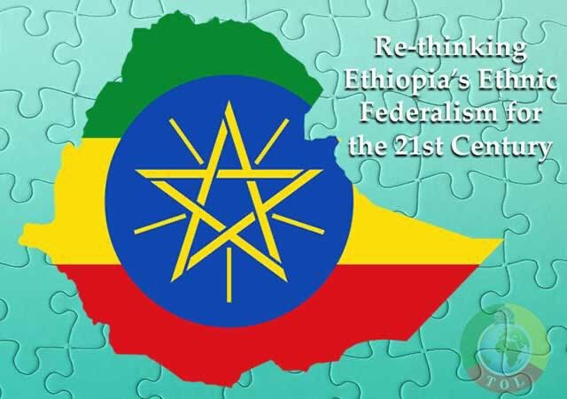

We now have a generation of Ethiopians who only know about tribe, instead of strong, consensus-based government of the people, for the people and by the people. The way it is now, the people of Ethiopia have been left out. This acts to further reinforce “ethnicity” in becoming the major organizing principle of the country, example being the issuing of “ethnic-based” identity cards. These ethnic policies undermine peace and harmony in the country.

Unity has also been manipulated to mean “one language [Amhara], one religion [Ethiopian Orthodox], and one [dominate] culture [Amhara], in order to ensure it is resisted and that it will alienate most people from coming to the table. This definition has been used to advance tribalism and the ethnic-based Constitution and ideology.

What this means is that we are not one people with anything in common, but a country of 87 ethnic groups. It pushes the belief that you are on your own and should just remain in your own territory. This is worse than South African apartheid. It is anti-humanity. To make matters worse, those who speak about unity are portrayed as the enemy, sometimes by their own groups, as well as by ethno-nationalists; shunning, shaming and disempowering the person, using accusations such as, “…these people want to take the country back to feudal times,” using it as a tactic to keep people apart. Those of more than one ethnicity are forced to choose between them.

To perpetuate divisions, some groups have been blamed, attacked and killed far more than others in this toxic system, a tried and true formula for deadly conflict. These groups are portrayed as the oppressors, seeking to take the country back to one language, one religion and one culture, even if it not true, and even if it is unworkable in the 21st century. As the accused perpetrators, they actually become the victims of the crimes at the same time.

The acclaimed victims become the perpetrators, a complete reversal. Not thinking about the future, because the next time it might be them. As collective groups are accused of either role, it is individuals, who buy in to the deadly narrative and then join with others, forming mobs to carry out the worst of it in places like in Burayu, Shashemene, West welega, Shewarobit, Metekel, Mikadra, Axum, Gurafereda, Gedeo, Tepi, Maji and etc.
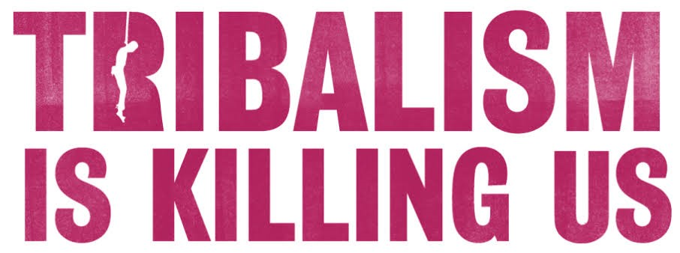

The truth is: we are all flawed and that is the reason we need informal and formal structures to bring justice, regardless of ethnicity or other differences; however, many of those being targeted in the last three years, were not being accused of any crime except of being the “wrong ethnicity in the wrong place.” If the goal being embraced is to incite the destruction of certain groups, truth makes no difference. Those wanting the destruction of Ethiopia are rewarded once again. They avoid culpability by simply standing by, pretending innocence.

Breaking Up Ethiopia: Pushing Ethnic Division

One of the primary groups being targeted now are the Amhara. The demonization of Amhara began decades ago with the TPLF and ethno-nationalists. Now, anyone who speaks about unity, no matter what ethnic group that person belongs to, is often accused of being an “Amhara sympathizer” and is condemned. As part of the deepening alienation targeting the Amhara, there has been massive pressure on the Amhara to abandon their ideology of Ethiopian national unity— Ethiopiawenet (አትዮጵያዊነት) a “oneness as Ethiopians.”

National unity has been redefined as the negative equivalent of “a win” for the Amhara, essentially meaning the return to the Amhara domination of the past. Some of the antagonism goes back to legitimate grievances occurring during the time of the Ethiopian Empires as well as during the Dergue; however, this should not hold all of us hostage, preventing us from creating a better and more inclusive government for all. However, the TPLF and ethno-nationalists continue to use this against the Amhara, who they view as contenders for power, while outsiders like Egypt, whose goal has been to destabilize Ethiopia, see the Amhara as an obstacle to the ethnic-based conflict that will Balkanize the country.

Crimes and attacks by ethno-nationalists continue to specifically target the Amhara. Those living outside the Amhara region have been the most affected. In these places, like in Oromia and Benishangul-Gumuz, they have been told to go back to their own region; that they were settlers and newcomers, not belonging in that region, even though some had been born there. Because this targeting continues to significantly increase, many of the Amhara are now organizing themselves by ethnicity, believing it must be done in order to protect themselves, also creating a stronger platform for advocacy when they can speak out as one group rather than as individual citizens. Their hope for a united Ethiopia has become secondary to their own survival. All of this is accelerated by the lack of protection from the government.

A government’s primary responsibility is to protect its citizens; however, it has failed in some regions. This trend is very dangerous. Again, this is not only the work of insiders, but has been promoted and supported for years by outsiders with their own agendas, sometimes effectively working with different partners from within, particularly those who do not want a strong, unified and prosperous Ethiopia; but instead, its weakening and break up so the flow of the Nile River and the domination of the Red Sea can remain in the hands of Egypt. Some who fall into this scheme, do not even understand their complicity with these external forces.

The Role of All Ethnic Groups, All Made Up of Individual Human Beings

The fact that the majority of the 87 Ethiopian tribes are left out of a conflict mostly perpetuated by the three major ethnic groups in the country, the Oromo, the Amhara and the Tigray, does not mean the rest of us will not be impacted if the country falls into chaos, violence and killing. In fact, the exclusion of the other groups has been a problem for years, especially worsened by the present ethnic-based Constitution and ethnic-based form of government that only pretends to care for the minorities. The truth of the matter is they do not care about them. In fact, the system of institutionalized tribalism has been used to negate the rights and representation of the many minorities; and oftentimes, to exploit them and their resources.

To the other 84 ethnic groups, with tens of millions of individual citizens, I ask, “Where are you?”

We cannot leave the country only in the hands of the three major players. The country belongs to all of us. No group should give the ownership of the country to one or a few ethnic groups.

This problem has made us land-locked. We are and have been needlessly fighting each other, especially where and when we have fallen for the brainwashing of outsiders. We should not fall victim to this seductive deception and manipulation of our grievances and weaknesses in order to defeat us.
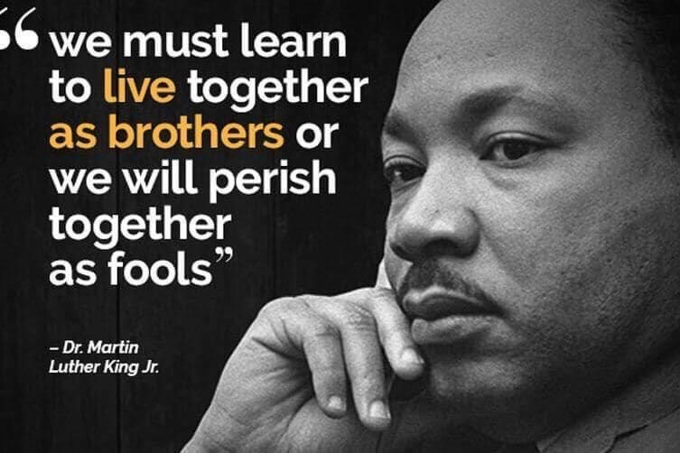
Imagine if Meles had dealt with Ethiopia as a nation, working for the common good? Instead, his efforts were to use ethnicity and victimhood mentality as a means to divide and conquer. It worked for nearly 30 years, with the impact still very much present in today’s crisis. Had the effort been to build the country, what could have resulted?

We may not have divided from Eritrea and could have had a country of more than 200 million as well as access to the Red Sea and its ports. We may have had much greater success in efforts to feed our people, to educate our children, to build stronger infrastructure, to better develop our economy and technology and to have a stronger and more advanced national military and regional security force that could have defended and protected its citizens instead of deliberately trying to break us apart by exploiting our unresolved tribal conflicts.

We could have been respected and feared for our ability to defend ourselves and as responsible models of more effective, just and wise governance, not only in East Africa, but also on the continent. It’s not too late! With genuine, non-tribal leaders, who care about the lives and wellbeing of every Ethiopian, with an inclusive Constitution, based on “we, the people, not the tribe,” with strong institutions that uphold the rights and value of all the people, and with God’s help, Ethiopia could rise up from the ashes of Ethnic Federalism.

Will Ethiopians stretch out their arms to God? With Him, all things are possible; but, the question is, are we willing?

Part II of this article will be released following this one and will focus on external forces that exert an influence on deteriorating conditions in Ethiopia.
__________________________________________________________
For more information contact Mr. Obang Metho, Executive Director of the SMNE. Email: Obang@solidaritymovement.org

