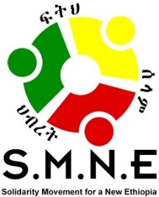

Mr. Obang Metho, Response to the Constitutional Debate:
“HAS THE COVID-19 PANDEMIC REVEALED THE DEEPER FLAWS WITHIN THE ETHIOPIAN CONSTITUTION?”
May 20, 2020

A newly invigorated media debate has emerged over the last three weeks. It centers on the impact of the second postponement of the national election, this time due to the Covid-19 pandemic. Delaying the election for an unknown period of time, possibly a year or more, will essentially leave the current members of the House of Peoples’ Representatives (Parliament) in limbo. Their five-year terms expire on October 5, 2020. What will be their status following that date?

In response, the government made the decision to seek a Constitutional interpretation in order to legitimize the extension of term limits in the House of Representatives until an election can be held; however, opinions and solutions differ on this decision and on the way forward.

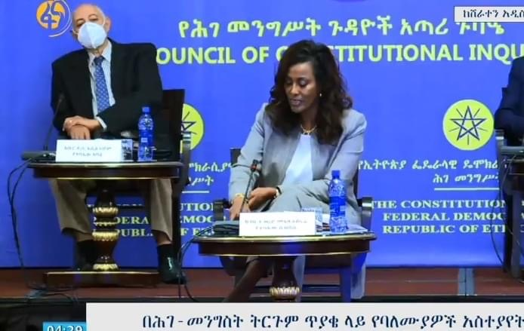

Constitutional guidelines are not clear some say. Others say these parliamentarians will not have the legal basis to remain in those positions, some adding their belief that the election was rigged in the first place, making it even less acceptable. Still others cite various articles in the Constitution as guidelines for more specific solutions; such as: 1) a Constitutional interpretation, the current choice, 2) an amendment to the Constitution, 3) calling for a state of emergency; now in effect; or, 4) for the recognition of governmental authority, as per the Constitution, to extend the term limits during such a crisis as long as certain safeguards and limitations on power are put in place.
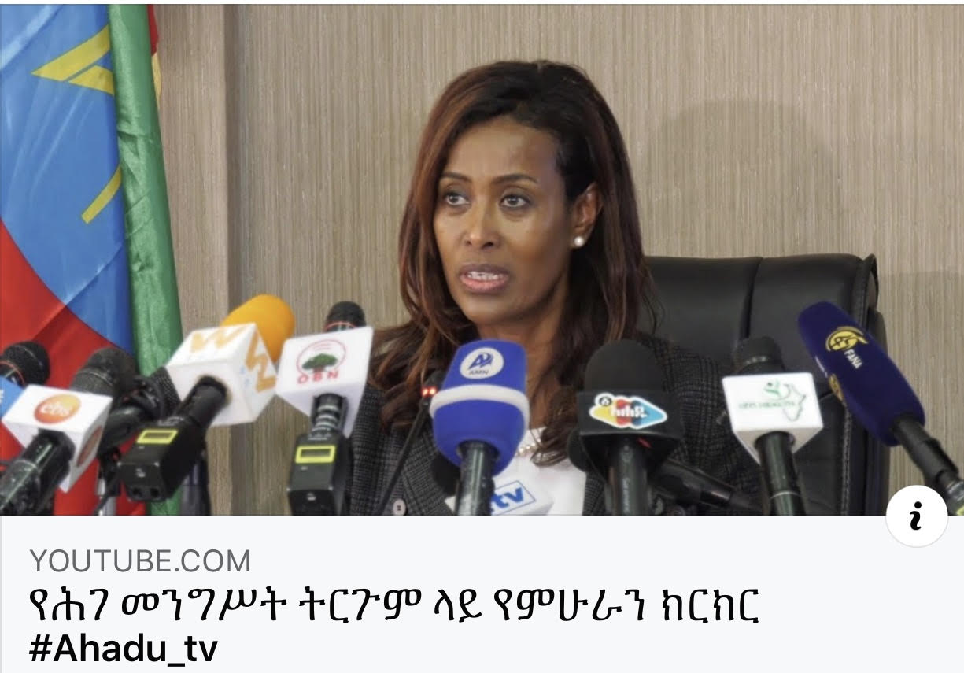

It gets complicated as there is no clear precedent; yet, there are many constitutional implications, political implications, power implications, many unknowns, and an overall lack of trust between and among the major players— the government, opposition groups like the ethno-nationalists and secessionists and the people. In fact, some political groups, like the TPLF, oppose the delay altogether and say they will hold the scheduled election in their region regardless of any decisions to the contrary. Without question, different power players will distrust the motivations of others, sometimes for good reason, especially in light of a past history where deceptive tactics have repeatedly led to power and resource grabbing.

We live under a “one winner take all” ethnic-based model of governance. All others become the losers— unless we change the model. Keep in mind, this model often even exploits one’s own group in order to fulfill the ambitions of a few. Unfortunately, too much of our future as Ethiopians depends on us; and face it, we do not have a good track record. A need a new approach and that will require self-examination. We must have the courage to look at ourselves rather than justifying wrongful intentions or actions by blaming others for doing the exact same thing. Victims and perpetrators can easily slide back and forth between both positions, so we must be careful, honest and humble.

It also may be tempting to use this crisis as an opportunity to advance self-interest or political ambition; however, when does it stop? It is unsustainable. What must be done for a better outcome? How can that self-centered side to every human being be better constrained, convinced or even inspired by moral, social, cultural, spiritual and legal principles and values, making it possible to bring greater unity around a common vision?

Here is the more important question before us:
“How can we, the people of Ethiopia, enter into an agreement of a common vision for Ethiopia that better ensures not only our own justice, freedom and rights, but also ensures it equally for all? How can we then integrate that shared vision into an enduring social agreement, a social covenant, that is interwoven into the fabric of our society?”

This is what we are missing. Does anyone think that some surface change or process will cover up what we all know and expect: that we can go through the motions; yet, end up recycling our past? Will we once again fail to affirm the humanity of others in our country, or will we invest in a more equitable future, putting humanity before ethnicity or any other differences because each of us is endowed with value and dignity from our Creator? Will we understand that our own freedom is not sustainable until all are free, meaning we should care about our neighbor’s rights like we care about our own if we are to live together in harmony?

We should follow a good constitutional process, with transparency, as we address the current crisis; however, if our vision is self-serving, politicized or inequitable; or, even if it only appears to be, the lack of trust and vying interests will repeatedly create new conflicts and obstacles. If we cannot agree on a common vision, we may go through the steps without ever finding our way.

In examining ourselves and our own positions, we should ask ourselves some important questions.

- What is our vision for the future?
- Who does it include? Who does it exclude, if any?
- Upon what is our vision based? Is it a higher truth, larger than ourselves and widely accepted us right, true and just?
- Does your vision further justice and the humanization of others beyond yourself and your own ethnic or other group? If not, how is it working for you, for your group, for others? Is it better or worse than in the past? Why?
- Could we find basis for agreement that could lead to a shared vision for our shared peaceful, harmonious and more prosperous future we could all embrace?
- How do we get there? Can we simply hope it works out or should we do more? What do you suggest?
- Where are we now as a country? What’s right about it? What’s missing? What can we do about it?
- As we look to the future, what must happen to best ensure a stronger and higher vision for all leads our decisions and actions, rather than the reverse, hijacking our hopes and dreams? What protections are needed?
- What can we do now during this time preceding the next election? How should it be done?
- What should be in place now for the best outcome later? Who should be involved?
- How could we gather the collective wisdom from respected Ethiopians in light of the current situation? How should they be identified and utilized? How can engage civil society to play a stronger role in this?

This might be a golden opportunity to focus on building the right foundation for an enduring democracy; something we have missed doing many times before; however, we now have another chance. Will we rise to the challenge to focus on a common vision for our country? Please understand; it is out of that vision that our value system will be clarified. Currently, we live in a system that favors certain groups at the expense of others. National identity and regional states have both been watered down to ethnic identity. No nation in the world can survive with mere ethnic identities being the organizing force; it is never equitable; it always leaves someone out.

The decision about the next election is highly charged. If history repeats itself, as it has over and over again, how can we really expect anything different from simply recycling our past? How can we move ahead without an intentional, genuine and thorough process—a national dialogue, starting at the local level— to develop a common vision we can agree upon as the people of Ethiopia rather than as separate ethnic groups living in Ethiopia as has been defined by ethnic federalism or ethno-nationalists? How can we be more unified unless we engage in a meaningful national process that focuses on reconciliation and restorative justice that addresses past grievances and how to correct a flawed system/mindset that perpetuates it, often based on things like ethnicity? How can we expect anything different from what we have unless we place a high priority on adopting Constitutional reforms as well as institutional reforms that address these inherent flaws?

Expect resistance. If you are in a position of power or expect to be a winner based on the current ethnic-based system, you may view genuine national reconciliation and the likes as a threat even while speaking the rhetoric of unity.
In other words, what we are suggesting may not make sense to those holding these views; because, as the saying goes, “It’s impossible to wake someone up from sleep if the person is only pretending to sleep.” Yet, because this is the exact kind of dialogue critically necessary to the formation of a common vision, in the best interest of all Ethiopians, why not start these dialogues now, in many different venues, led by many different stakeholders and on many different aspects? Horizontal dialogue among the people is the most important place to start.

We, the people of Ethiopia, must take a place in this debate for the simple reason that we care about the wellbeing all our citizens who live in this ancient land that has lost, or maybe never found, its way. Many of us dream for a better Ethiopia so when things like these issues require our participation, we are willing to do our share. We know we are flawed people and hold responsibility for many of our problems; however, we should not allow ourselves to be held hostage by the negative part of our history.

Here’s why this constitutional crisis is not just about Covid-19; but instead, serves to better clarify to us how important it is to “fix” our broken system.

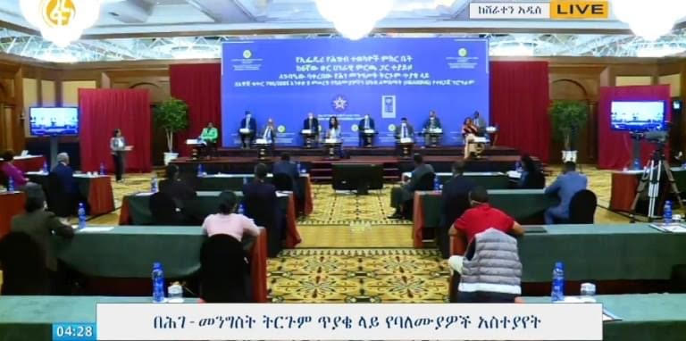

Ethiopia, is a country with an ancient history; yet, we remain stuck in a self-defeating pattern of governance that has mainly elevated those to power who have subsequently put their own self interests or their tribal interests ahead of national interests. This means the wellbeing of the Ethiopian people has repeatedly been violated or reduced to an “issue” of unimportance. The evidence of this is everywhere.

Why do you think we still rely on outsiders to bail us out of our problems, like our chronic inability to feed ourselves? We are a country with periodic famine, why do we not better prepare? Why are we still tilling the soil, using ancient methods? Why do we need all kinds of foreign aid to close the development gap in most sectors of society? Why do we still have tribal-based violence? Why has corruption been such a huge problem over the past decades, including financial leakage from aid we receive from foreign sources? Why is it that ethnicity— not citizenship and residency— makes the difference in whether or not one can vote in the region where one lives? Why does ethnicity, not competence, determine who gets hired for many jobs? Why is the application and outcome of the rule of law dependent on tribal politics? Here is one for today: why are the disagreements on how to solve our present Constitutional crisis so closely related to tribal affiliation?

Obviously, we have a Constitution that promotes ethnic-based hegemony—one tribe take all— and one that undermines the rights of others, inevitably leading to conflict at every level. The only time there may have been an attempt to reform this system was with creation of states under Menelik. The Derg wrote their own Constitution and then the EPRDF did the same, slanting it to their own advantage.
The current Constitution of Ethiopia does not enable the wellbeing of all; but instead, separates people, diminishes the humanity of others, and is driven by personal interest while masked by tribal interest so as to fulfill material wants and ambition for power. It does not ensure individual rights; but instead, it favors tribal rights for the winners and their cronies.

Deception was utilized to strip the Constitution of individual rights as citizens of a nation, replaced with recognition of ethnic-based collective rights, supposedly leading to greater self-determination. What really happened was the weakening and disenfranchisement of most ethnic identities by those in power— who never failed to have their own sympathetic ethnic representatives in control of regions and localities. This ethnic-based Constitution is an instrument for inequality and has been so seriously abused, it has pushed us near to collapse.

Through an unexpected series of events, the Covid-19 health crisis has arrived at the same time as the national elections were to take place. This crisis has also come at a time when we have a different kind of leadership, led by Prime Minister Abiy Ahmed, that has emerged from that flawed system, bringing about a different kind of response this time, even forming a new party, the Prosperity Party, indicating a desire to break ties with the past.

The National Ethiopian Electoral Board has now postponed the election and the government called a State of Emergency. The prime minister deserves our appreciation because of his willingness to open up more dialogue and also because of the leadership choices he made for appointments to key positions such as Meaza Ashenafi, the President of the Supreme Court; Birtukan Mideksa, Chairperson of the National Electoral Board of Ethiopia (NEBE); Filsan Abdullahi, Minister of Women, Children and Youth of Ethiopia Daniel Bekele, Chief Commissioner of Ethiopian Human Rights Commission; Dr. Liya Tadesse, Minister of Health of Ethiopia and many more. These current leaders in these strategic positions were once considered criminals under this Constitution for defending the rights of the people and calling for meaningful reforms.

In the past, debate about the Constitution was out of the question; however, we are now hearing different perspectives from many legal experts and scholars as they enter in to a healthy dialogue. The present Constitution, though flawed, is the only one we have; however, this present discussion is an indication of its importance in navigating new waters. As such awareness is heightened, a new vision and reformed Constitution may take the stage along with the strengthening of institutions to support it.

In doing so, the peoples’ ability to influence the process, and hopefully the outcome, has been strengthened in an unprecedented way. It has also brought a new level of scrutiny to the Constitution. This is a gift from God, a historical Constitutional moment; maybe the time for which we the people of Ethiopia have been waiting.

For now, the House of Federation (HoF) will ask for an interpretation from the Council for Constitutional Inquiry (CCI), which will then be brought back to the HoF for a vote rather than leaving the final decision in the hands of the Supreme Court. Again, the process and setup of these branches need to be examined as one may wonder why the Supreme Court does not have the power vested in them to make legal decisions like done in other healthy, democratic countries in the world; yet, the fact that this process is being made transparent and followed is historic.

The ethnic federalism Constitution we have now in Ethiopia is based on victimhood, distrust and how to recover and maintain power for some, but not for others. In most of the free countries, the Supreme Court makes the decision on the Constitution; but here, the future of the Constitution is intentionally left in the hands of the House of Federation (HoF). Why? Is it because the HoF represents ethnicities; and as a result, advances tribal agendas? This is a distinct advantage to the majorities as well as to the most powerful, usually the incumbents, if they are able to exert control over the members. Eighty-six different ethnic groups are represented; however, if a group has over a million members; for every added million, that group is allowed another member. This was obviously done to ensure the maintenance of tribal interests.

The House of the Peoples’ Representatives (HoR) consists of 547 elected members who are responsible for the passing of laws; however, unlike the HoF, they have no say in any constitutional matters. It is probable that the reason for this “arrangement” was fear that if judicial power were to be given to the Courts, it would likely threaten the tribal interests being advanced in the Constitution; and subsequently, lead to reforms. On the other hand, because the HoF was already built on the foundation of tribal interests, they are the only ones with the legal authority to amend or interpret the Constitution, leaving a power advantage to them.

Currently, we have two main stakeholder groups; those wanting to hold on to the present Constitution and those wanting to put individual democratic rights first. Previously, the latter group did not have a seat at the table; but instead, were left out by ethnic-based secessionists and non-nationalists. The ethnic federalism model was victorious, explaining our current Constitution. The voices of those wanting an inclusive nation for all the people were blocked; however, thanks to Covid-19 and Prime Minister Abiy, we now have a new opportunity to build a nation for all its people.

A recent writer, Mekuria Gize, asked the question as to whether Force Majeure, meaning unforeseeable circumstances, like Covid-19, that would prevent someone from fulfilling a contract, could justify the continuation of PM Abiy’s government. Currently, one could view the relationship between the people and the state— and its Constitution— as a social contract that would be broken due to circumstances in which we now find ourselves.

This may be necessary at this time; however, what is being suggested in this article is the need for a higher agreement, a social covenant, defining who we are and our vision of, for and by we the people. If we had such an agreed upon social covenant, it could carry us through this difficult time; however, because we do not, we are left in a precarious place with concern that someone else will step on or over us— and our basic human rights— to take what is wanted from the rest of us. No wonder we continue to see ethnic violence and displacement in many places. Everyone is afraid of losing, from the most powerful to the least powerful. This “force majeure” may be “forcing us” to consider coming together in a national dialogue, not only carried out nationally, but especially at the grassroots level, to see if we can agree on a common vision—a social covenant— that is inclusive for all the people of Ethiopia.

Would opposing groups be able to actually collaborate on overcoming such challenges as Covid-19, its impact on the elections and subsequent power, if they were confident that they would be fully included in the same benefits as all citizens of Ethiopia in the future? Some may be greedy for more, but if we could find overwhelming agreement for an equitable system and one that held us all accountable, would it not ease current and future tensions among us?

It is time for Ethiopians to get it right. A contract is often broken, but a covenant goes much deeper and is built upon a system of values and universal principles that could unite the people of Ethiopia across previously divisive lines of ethnicity, language, culture, religion, region and other differences. It would be the first time in a thousand years.

We are at a crossroads; one direction will keep us circling back to the same crisis over and over again. Let us seek righteousness’s way to build a new Ethiopia and united nation where we care about our neighbors as we do for ourselves, for no one will be free until all are free.
================================ END==================================
Mr. Obang Metho, is Executive Director of the Solidarity Movement for a New (SMNE) a grassroots social justice movement of diverse Ethiopians whose mission is to advance the freedom, truth, justice, human rights, civil rights, equality, accountability and reconciliation of all the people of Ethiopia, regardless of ethnicity, religion, political view or other differences.

The SMNE is based on the belief that the future wellbeing of our Ethiopian society rests in the hands of those among us who can put “humanity before ethnicity,” or any other distinctions that divide and dehumanize other human beings from ourselves; inspiring us to care about these “others;” not only because of the intrinsic value of each life, but also because “none of us will be free until all are free.”

