Mr. Obang Metho offers his best wishes for the Ethiopian New Year 2012.

Hope for 2012: A Just Ethiopia for All Its People!

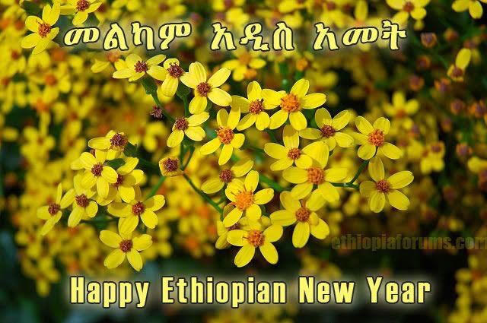
September 11, 2019

As Ethiopians across Ethiopia and throughout the world gather with family and friends, I want to wish everyone a very happy and healthy Ethiopian New Year. This is always a hopeful time, as we celebrate the end of one year and the beginning of another. Even though 2011 was difficult for millions of Ethiopians, we must also look back on this year with the knowledge that brighter days are ahead of us. Although our current challenges of ethno-nationalism and others are greater than ever before, each of us Ethiopian from every ethnic and religious groups must have the courage and determination to rise up and meet them. It is that spirit of (Ethiopiawinet) or togetherness that has kept us together as proud Ethiopians for generations, and it is that Ethiopiawinet spirit that will keep Ethiopia together for generations to come.

Prime Minister Abiy Ahmed and his team of change makers unexpectedly came to power in 2010, Ethiopian (Gregorian) calendar and 2018 in Julian calendar, bringing excitement, joy and hope for the future beyond the imagination of Ethiopians.

At the beginning of 2010 Ethiopian Calendar and 2018 Julian calendar, no one would have thought that months later, thousands of political prisoners would be released or that peace talks between Ethiopia and Eritrea would help restore a longstanding hostile relationship between neighbors or that information would begin to flow with an opening up of the media or that opposition leaders and human rights advocates, previously denied entry into the country, would suddenly be welcomed back. It seemed impossible; yet, as these initial steps of democratic progress were taken, expectations for the future soared, only to magnify the disappointment when problems continued in certain areas.
Who said it would be easy? Transitioning from repressive structures of government based on ethnicity, put in place over the last 27 years, to a working democracy is not easily accomplished. Along the way, we have seen strongholds of resistance to that change from embedded structures, mindsets, vested interests, and habits of the past, all of which have lingered on, becoming obstacles to change. Bright hopes for speedy change have rapidly diminished as human impacts are seen and felt by many.

After the 2011 Ethiopian New Year, we saw one of the worst impacts from the rise in ethnic fighting as tensions between groups increased. It resulted in the internal displacement of more than two millions of Ethiopians from various places across the nation, particularly in the South. As PM Abiy tried to unite the people; ethno-nationalists were trying to divide them. Now we are witnessing the harvest of what was planted by a system built on the foundation of ethnic hatred and ethnic nationalism. It is dangerous.

Ethno-nationalism may have been a factor in the assassination of the president of the Amhara region and his attorney general as well as the assassination of the head of Ethiopian army and his advisor; all of whom may have been threats to the rising ethnic extremists. This barbaric violence has shocked the nation and is threatening the legacy of harmonious co-existence among the diverse people in this country.

It has not yet been addressed and must be if we are to see peace and stability established in Ethiopia, without which there can be no sustainable prosperity. At the core of this impasse is a Constitution which is set up on the basis of ethnicity. It must be challenged and changed in order to create institutional structures that promote justice for all people. Those who believe in ethnic nationalism are holding on to it while others are looking for way to simply live together.

Right now, most everything in Ethiopia is based on ethnicity; for example:1) the Preamble to the Constitution, 2) the demarcations of the states, which are based on ethnicity, not geography, 3) the political parties, including the ruling party which is based on ethnicity and is not inclusive of the majority of ethnic groups, 4) the media, which is organized around ethnicity and tends to be biased towards promoting its own interests above any national agenda, 5) the banks, which are named after ethnic groups, 6) sports clubs, which are now organized by ethnicity, and now, 7) some want to organize religion based on ethnicity. Our Creator does not have ethnicity, but created us as human beings equal.

At the same time as many Ethiopians are focusing on ethnicity; people are forgetting about other issues of importance like jobs and the slowing economy. Unemployment is extremely high, especially among the young who make of 70% of the population. Now, add to this the challenge of holding an election in May 2020 when there is still no consensus about a great many important issues; neither has there even been a genuine, in-depth dialogue on what the basic structure of our government and the Constitution should be.

Ethiopia should be moving away from tribal-based or personality-based politics to more principle and idea based platforms. Additionally, our regional states should be changed to be based on geographical boundaries rather than based on ethnicity. Anyone should be free to live wherever they want, which will require private land ownership rather than government ownership of all land. Similarly, jobs should be given based on competence rather than ethnicity.

If these issues are not resolved, it can create more problems; like in the Southern region of Ethiopia, where 10 different ethnic groups are asking to form their own regional state because they believe it may be the only way to be treated fairly.

All of these tensions will only worsen if some of these issues are unresolved prior to the election. Many worry that competing ethnic groups within regions or among regions may not be allowed to freely campaign without the permission from the local ethnic groups, causing some to worry that the election may lead to instability. We must talk about these issues, especially where there is hostility and resentment. Avoidance can be more dangerous.

Knowing this, people must work very hard to bring meaningful reforms, including Constitutional and institutional, which will lead to greater justice, peace and reconciliation to the people of Ethiopia. This also will require self-examination of oneself so as to go beyond self interest or ethnic interest at the cost of justice. Key stakeholders must see the bigger picture and have a greater responsibility to advance truth and justice for all.

In closing, we cannot simply wish for a better 2012 Ethiopian calendar, but we must seriously work together on common vision and national unity, especially as we face a crisis of ethnic-extremist competition that could bring our mutual downfall like that of Syria, Libya and Yemen. Do we want Ethiopia to be added to that list? Where are we going to run to next if that happened?

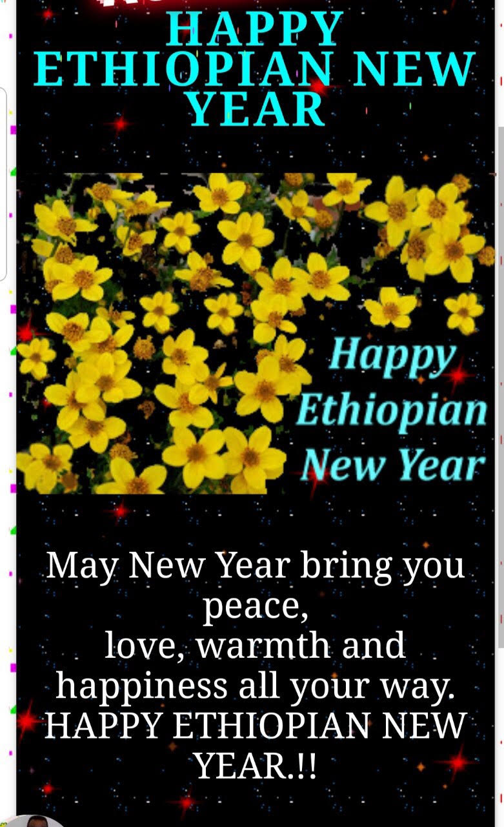

President Thabo Mbeki of South Africa recently said, “Ethiopians need to focus their energy on common vision and national identity not ethnic identities. Ethiopia cannot fail and must not fail.” He meant that the consequences of our failure would not only be disastrous to Ethiopia and East Africa, but would affect the whole continent. We have a responsibility beyond ourselves.

May God help us to follow universal principles of valuing the humanity of others, putting humanity before ethnicity or any other differences and caring about these others like we care about ourselves, not only because it is right thing to do, but because no one is free until all are free. May this be the year that the leaders and the people of Ethiopia humble themselves to see beyond their own interests for the common good of all.

